|  |  |
| --- | --- |
| **document** | **window** |
| It represents any HTML document or web page that is loaded in the browser. | It represents a browser window or frame that displays the contents of the webpage. |
| It is loaded inside the window. | It is the very first object that is loaded in the browser. |
| It is the object of window property. | It is the object of the browser. |
| All the tags, elements with attributes in HTML are part of the document. | Global objects, functions, and variables of JavaScript are members of the window object. |
| We can access the document from a window using the window. document | We can access the window from the window only. i.e. window.window |
| The document is part of BOM (browser object model) and dom (Document object model) | The window is part of BOM, not DOM. |
| Properties of document objects such as title, body, cookies, etc can also be accessed by a window like this window. document.title | Properties of the window object cannot be accessed by the document object. |
| syntax:        document.propertyname; | syntax:  window.propertyname; |
| example:       document.title :  will return the title of the document | example:  window.innerHeight : will return the height of the content area of the browser |

**Difference between document and window:**

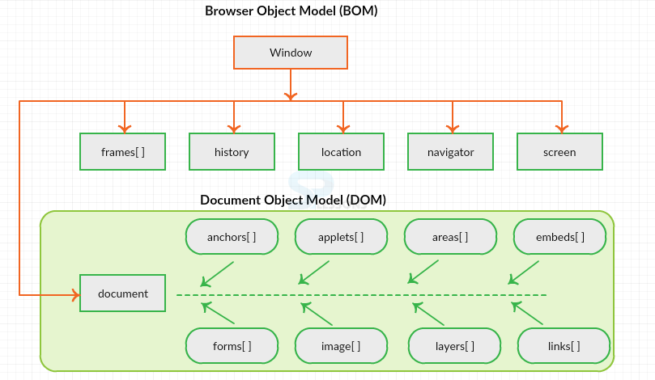 **How BOM and DOM Works in Browser:**